**20. Information Retrieval Using TF-IDF**

**Aim:**  
To create an information retrieval system using TF-IDF for document ranking.

**Algorithm:**

1. Import TfidfVectorizer from scikit-learn.
2. Prepare a set of documents.
3. Compute TF-IDF scores for each document.
4. Rank documents based on relevance to a query.

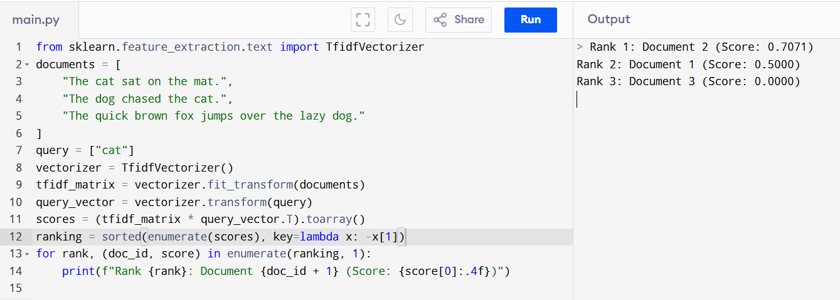

**Result:**  
The TF-IDF system ranks documents based on their relevance to the query.